**LOTOMATIC**

USER:

1. When open the app this is our first page. In this page should get a notification allow permission from the user like below attach screen.

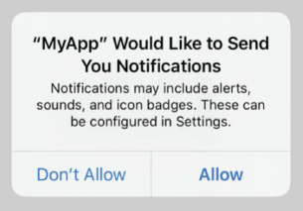

1. If they click allow then we send the notification.
2. In case the user click Don’t allow means should notification like below attach screen.

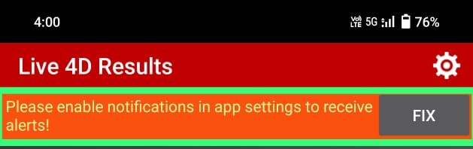

1. First should like below image.

4.1) Change the name Results to Lotomatic.  
4.2) In right side refresh, last 7 days result view in calendar icon, share option in share icon. Refer below images for calendar and share.

4.3) After header icon should change icons into our brand logo for three category all category having same logo. Scroll right the next category will be shown.

Above step for all.

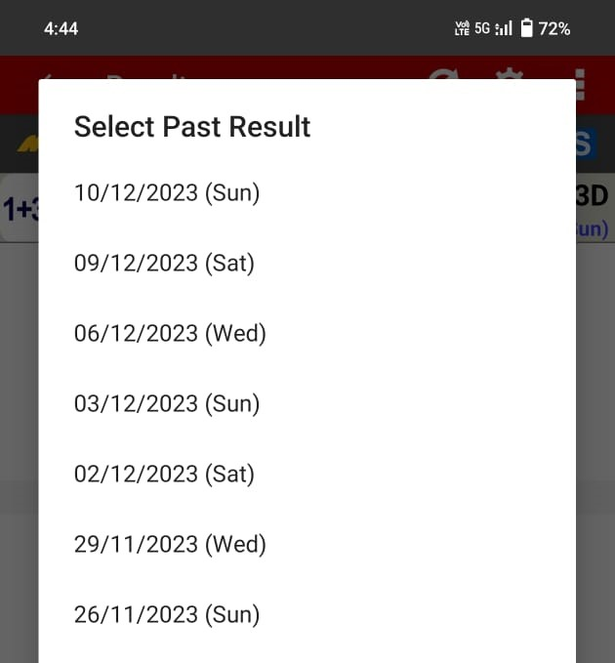 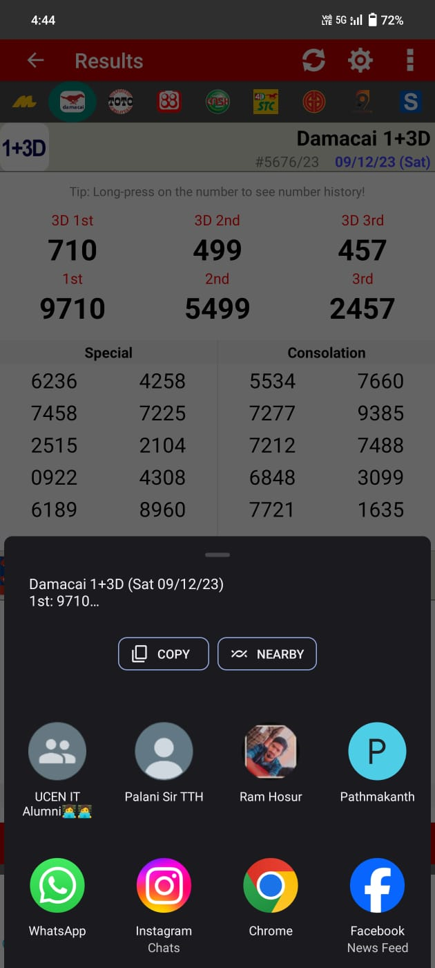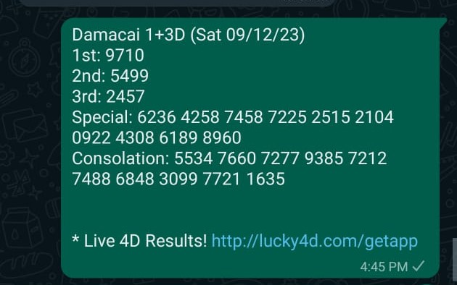

Below step for first logo.

5.1) Next change Magnum 4D to Lotomatic 4D.

5.2) Remove #966/23, left side corner logo and Tip.

5.3) 1,2,3 prices, special (10) and consolation (10) are getting from database based current date. Result should be 4digits. Total 23 result.

5.4) Next change Damcai 3+3D to Lotomatic Gold.

5.5) Remove #5677/23, left side corner logo.

5.6) For Lotomatic Gold have only one result with 6 digits.

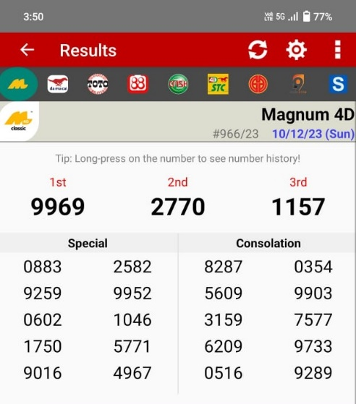

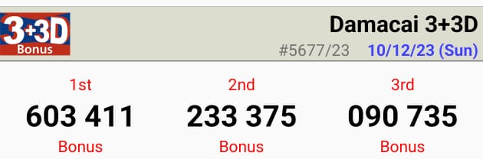

For second category.

6.1) Next change Damacai 1+3D to Lotomatic 3D.

6.2) Remove #5677/23, left side corner logo and Tip.

6.3) 1,2,3 prices, special (15) and consolation (15) are getting from database based current date. Result should be 3 digits. Total 33 result.

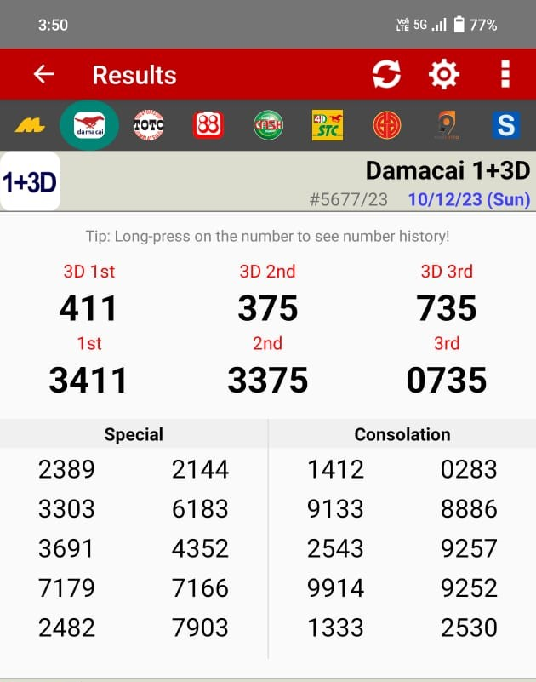

For third category.

7.1) Next change Toto 5D to Lotomatic 5D.

7.2) Remove #5730/23, left side corner logo.

7.3) 1,2,3,4,5,6 prices with some empty digits are getting from database based current date. Result should be 5 digits. Total 6 result.

7.4) Next change Toto 6D to Lotomatic 6D.

7.5) Remove #5730/23, left side corner logo.

7.6) 1,2,3,4,5 prices without first other have or condition with some empty digits are getting from database based current date. Result should be 6 digits. Total 5 result.

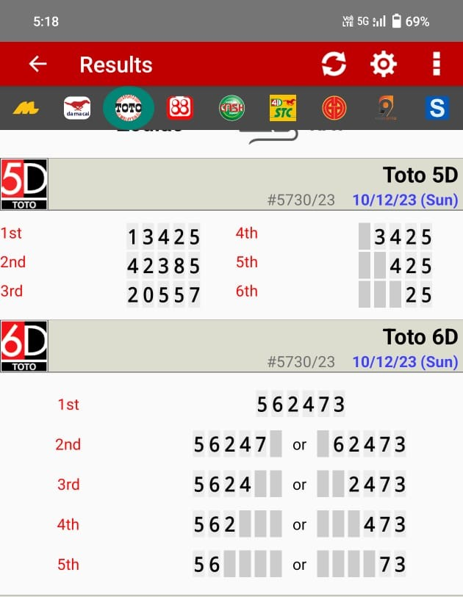

USER:

1. In books paradise admin add one more module for result update. (Result)

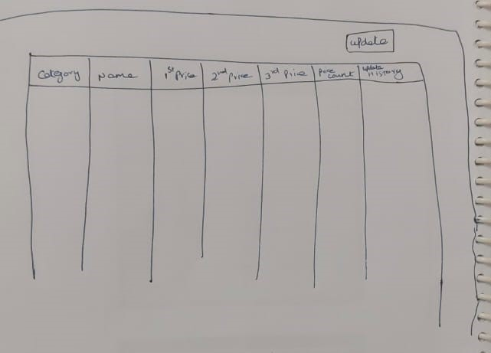

1. In category column should mention the category.
2. Names like Lotomatic 3D, Lotomatic Gold, Lotomatic 4D, Lotomatic 5D, Lotomatic 6D..etc
3. 1,2,3 price will be mention.
4. Total price count. Eg: 23
5. In history column shown the updated history (Only date).
6. Whenever click the update button. New screen like below.

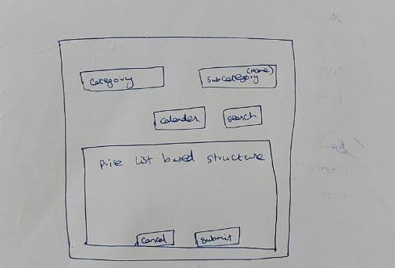

1. Select the category based on category select sub-category (Eg: Lotomatic 3D) and select the date from calender and search.
2. Based on search get the price structure (Eg: 1,2,3 prices, special (10) and consolation (10))
3. Once click the Submit button should send a notification to user ““**Name**” New Result has been Updated”.